**A Review on various Aspects of MongoDB Database – A Literature Review**

MongoDB is most popular among the NoSQL databases. For building data warehouses, it is a great tool especially because of its ability to fully utilize so called sharding-nothing cluster architecture. It is an open source database, which makes it ideal for building high performance data warehouses. (Chauhan, 2019)

In this paper, a review of various aspects of MongoDB is discussed and some key issues are framed. So this paper opens some areas for research in MongoDB databases.

**Introduction**

MongoDB is an open-source document database that provides high performance, high availability, and automatic scaling. In particular, it supports for embedded data models reduces I/O activity on database system, indexes support faster queries and can include keys from embedded documents and arrays. Rich Query Language – MongoDB supports a rich query language to support read and write operations (CRUD) as well as Data aggregation, Text Search. A replica set is a group of MongoDB servers that maintain the same data set, providing redundancy and increasing data availability. (Chauhan, 2019)

**Overview of MongoDB**

Dynamic schema means that documents in the same collection do not need to have the same set of fields or structure, and common fields in a collections documents may hold different types of data. MongoDB is a cross-platform, document oriented database that provides high performance, high availability and easy scalability. (Chauhan, 2019)

{

_id:ObjectId(7df78ad8902c) Title:MongoDB Overview

Description: MongoDB is no sql database Comments: [

{ user:user1,

Message:my first comment, dateCreated: new Date(2011,1,20,2,15),

},

{ user:user2,

Message: my second comments

dateCreated: new Date (2011,1,25,7,45),

}

}

**Advantages of MongoDB**

1. Advantages of MongoDB over RDBMS can be described as: MongoDB is a document database in which one collection holds different documents.
2. MongoDB supports dynamic queries on documents using a document-based query language that’s nearly as powerful as SQL.
3. Any relational database has a typical schema design that shows number of tables and the relationship between these tables.

**Uses of MongoDB**

1. MongoDB has document oriented storage; data is stored in the form of JSON style documents.

**Importance of MongoDB**

1. The leads to lessons like: data organization relative to query patterns, indexing options, handling polymorphic objects in code, performing manual joins on the client.

**Sharding**

Distributes a single logical database system across a cluster of machines Uses range-based partitioning to distribute documents based on a specific shard key Automatically balances the data associated with each shard Can be turned on and off per collection(table) This leads to lessons around things like write safety, handling master fail-over, shard keys and shard balancing.

**Comparative Study**

The NewSQL approach on the other hand, conserves and supprts the properties of relational model, at the same time incorporating the features of NoSQL model. In the classical RDBMS model, the data is organized in the form of relations and is represented in a table consisting of rows and columns. There are four main operations used to access the database they are known as CRUD namely, Create, Read, Update and Delete associated with the data.

As shown in Table 1, in MongoDB, some MySQL terms, such as table or row, get another name, namely collection, respectively BSON document.

In other words, we can say that MongoDB contains collections, collections contain documents and a document contains multiple fields.

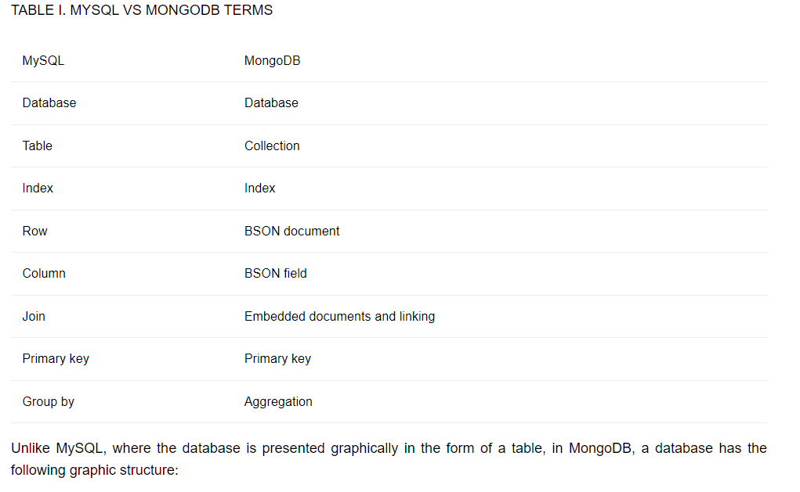

{

_id: d4acaf3a76e4378b853eb15fde21672, username: andra,

email: andra@gmail.com,

}

{

_id: d4rvgf3a76e4378b853eb15fde21672, username: iona,

email: iona@gmail.com,

}

The example above shows a database for users, each user having an id that is unique and automatically generated, a username and an email address.

1. Using MongoDB, these fields regarding the forum and subforum will appear only to users who have that right (moderators and administrators), thus significantly reducing storage space, which is much higher using MySQL.
2. If a relational database has been used, the columns for forums and subforums should have appeared at all forum users, although normal users will never have the right to create, modify or delete them, unless of course, they are the administrators of that particular forum.
3. MongoDB provided lower execution times than MySQL in all four basic operations (Insert, Select (query), Update, Delete), which is essential when an application should provide support to thousands of users simultaneously.
4. Within a subforum, the moderators have the right to edit/delete the subforum and they can also moderate other users discussions, while regular users are only allowed to post discussions and leave comments.

**Issues with MongoDB**

1. While this allows for greater flexibility with your data models, it forces more schema based design decisions on the app logic than the db.
2. Problems with Schema-less Design Since MongoDB is denormalised, it does not adhere to a relational schema.
3. This makes for faster lookups as Mongo doesnt rely on expensive join operations seen with MySQL and other database engines.
4. It has denormalised, meaning data is stored in a nested document structure rather than relational tables.
5. Without the schema in place, the rules and regulations of your data models are dictated by your app logic rather than the db itself.
6. Despite such strengths, there are several problems with MongoDB that one should consider using it as a database engine. (Chauhan, 2019)

**Conclusion**

The result of this study open new avenues for future research of performance of data access when there are hotspots in data because it supposes all the data will be accessed in same patterns. It is a great tool for building data warehouses, especially because of its ability to fully utilize so called shared-nothing cluster architecture. It is an open-source database, which makes it ideal for building high performance data warehouses. The next generation NonSQL (NoSQL) databases are mostly non-relational, distributed and horizontally scalable and are able to satisfy most of the needs of the present day applications. MongoDB is a relative newcomer in the database arena, and is the most popular among the NoSQL databases.

The main characteristics of these databases are schema-free, no join, nonrelational, easy replication support, simple API and eventually consistent. (Chauhan, 2019)

# Bibliography

Chauhan, A. (2019). A Review on various Aspects of MongoDB Database.

Related link- https://www.ijert.org/a-review-on-various-aspects-of-mongodb-databases